MINISTRY OF EDUCATION AND SCIENCE OF UKRAINE

NATIONAL TECHNICAL UNIVERSITY   
“KHARKIV POLYTECHNIC INSTITUTE”

Department of Software Engineering and Management Information Technology

REPORT

on laboratory work # 2

on the discipline

“python frameworks”

Executed by

Student of the group KN-218g.e

Karyna OHOL

Checked by

Ass. Prof. of department “SEMIT”

Svitlana KOVALENKO

Kharkiv 2020

Basics of the NumPy library

**Goal:** Obtain experience in working with NumPy library

Tasks

1. Perform a set of exercises.

2. Solve the system of linear equations using Cramer's formulas and perform a test using:

a) matrix multiplication;

b) numpy.linalg.solve().

3. Calculate the value of the matrix expression.

4. Solve the matrix equation using an inverse matrix and perform a test using: a) matrix multiplication;

b) numpy.linalg.solve().

5. Place the created notebook on GitHub

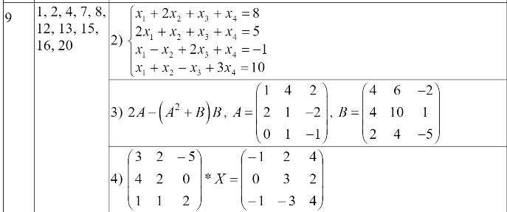

**STEPS**

1. Implementing training tasks (figure 1)

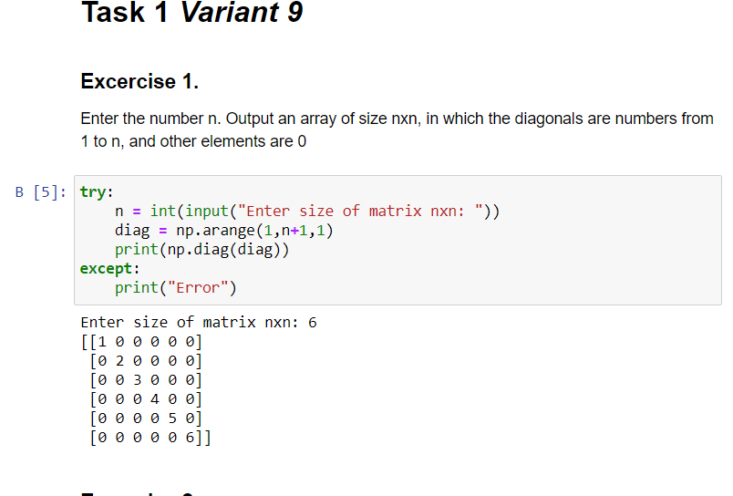  
Figure 1 – Implementation of training exercises

2. Implementation of formulas using Markdown’s LaTex (figure 2).

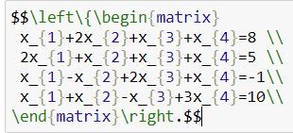

Figure 2 – Created formula notation in Jypiter Notebook

3. Solving given linear equations using matrix multiplication and numpy methods (figure 3)

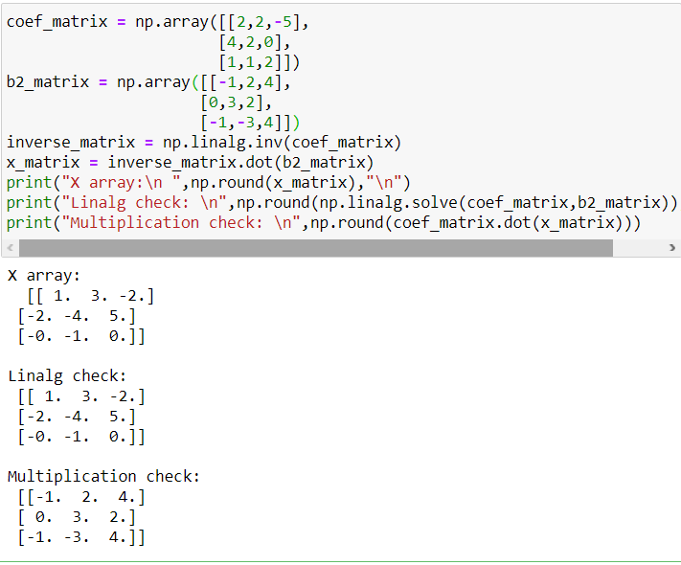

Figure 3 – Implemented functions for solving linear equations

4 Repository on GitHub - https://github.com/KarynaOhol/Pythonframework-.git

**Сonclusions**

NumPy is a large library that provides huge amount of different features and during this laboratory training only a few of them were implemented. However even created programs are small and readable, but provide complex functionality. NumPy realize many methods, that are usually required to work with collections of information. Moreover, these methods are efficient in terms of speed and memory consumption. To conclude, it is important to know at least basics of working with this library, as its features can be used in a variety of different tasks.